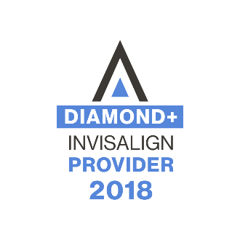
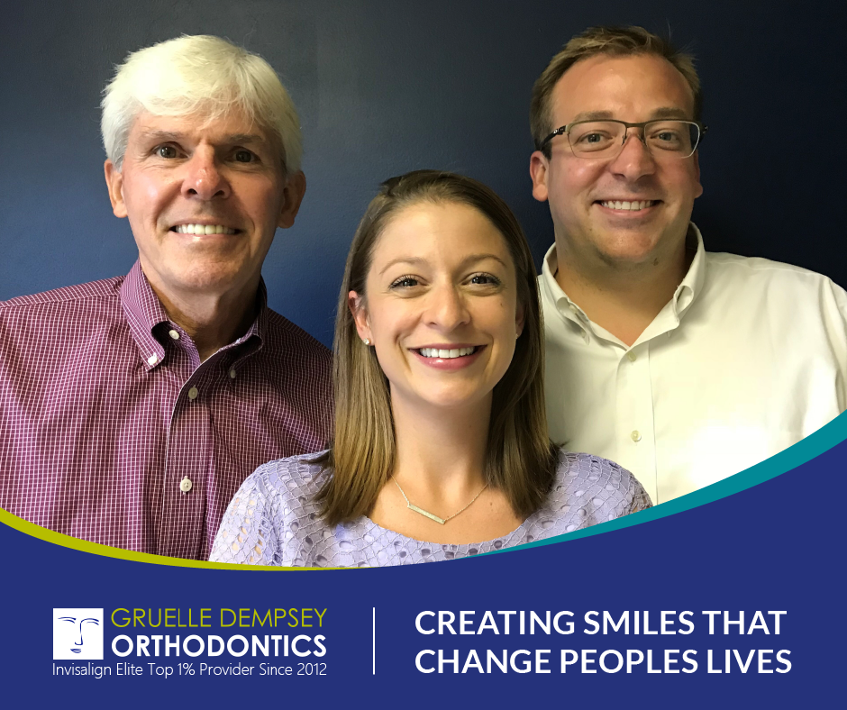
Gruelle Dempsey Orthodontics is a worldwide leader in Invisalign treatment and training. They have been Elite top 1% invisalign providers since 2012 and have treated over 4000 invisalign cases lifetime. They strive to be on the cutting edge of technology in orthodontics, and that is why they have fully embraced invisalign treatment in their practice. They have trained over 1000 dentists and orthodontists both locally and worldwide on how to “make invisalign work for them” in their practices, and they enjoy the teaching aspect of orthodontics as much as the treatment side. Dr. Gruelle has been lecturing for invisalign for 6 years now and will be speaking at the annual invisalign orthodontic summit in Las Vegas in November. Dr.’s Gruelle and Dempsey are excited about the direction that orthodontics is going in, and are pleased that they have been chosen for several pilot studies for invisalign, including early childhood treatment or phase 1 utilizing invisalign (invisalign first). Dr.’s Gruelle and Dempsey look forward to sharing about the utilization of invisalign in their practice as well as some cutting edge looks at what’s to come in the near future.

Dr. Terry Gruelle D.M.D., M.S.
Diplomate, American Board of Orthodontics
Dr. Jerrod Dempsey D.M.D., M.S.
Dr. Ashley Mencarelli D.M.D., M.S.

7205 Dixie Highway 40 North Grand Avenue 9675 Montgomery Road
Suite 1 Suite 301 Suite 100 12105 Sheraton Lane 1163 Fehl Lane
Florence, KY 41042 Fort Thomas, KY 41075 Montgomery, OH 45242 Springdale, OH 45246 Anderson, OH 45230
859.371.3677 859.441.2369 513.891.2369 513.671.6722 513.231.0041

website: www.gruelleorthodontics.com
email: gruelledempsey@tsortho.com

